**King's Surgery**

Port Talbot Resource Centre

Moor Road

Port Talbot

SA12 7BJ

Tel: (01639) 821489

Fax: (01639) 816399

Email: [enquiries.w98041@wales.nhs.uk](mailto:enquiries.w98041@wales.nhs.uk)

www.kingssurgeryporttalbot.wales.nhs.uk/



**Dr Craig Jeffrey Davies**

M.B., B.S.

Registered London 1998

Full time Partner in non-limited Company

**Dr Amatulla Fatema**

M.S., B.S., M.R.C.G.P

Full time Partner in non-limited Company

**Dr Vanitha Samuel**

M.B., B.S., M.R.C.G.P., D.R.C.O.G., Dip, DM

Full time Partner in non-limited Company



*The Resource Centre and King’s Surgery caters for those in wheelchairs and who have poor mobility*

The Resource Centre and King’s Surgery caters for those in wheelchairs and who have poor mobility

***Reception Opening Hours***

Monday to Friday 8:30am until 6:00pm

**Telephone line Hours**

Monday to Friday 8.00am until 6.30pm

**How to Register -** You will be requested to complete a Health questionnaire and arrange an appointment to see the Health care support worker (HCSW) or Practice Nurse for a health check. We require this initial visit with the HCSW or Practice Nurse to ensure we are aware of any known medical conditions and exclude others. If you are receiving any regular medication you will also need to see/speak to the Doctor, after your assessment with the HCSW or Practice Nurse, to have this medication updated onto your repeat medications. Please note it may take up to 6 weeks for your records from your previous surgery to arrive with ourselves.

**To request a consultation** for consultations – routine or advanced / non urgent prescriptions / enquiries:

Telephone – by contacting the receptionist, slots are booked via them.

For GP and Physician Associate – lines open from 8am. Please ring after this time for a triage slot. If under 16 years of age/over 75/ severe mental health or palliative care, please inform the receptionist who will inform the clinician and offer a same day assessment.

For Practice Nurse or Health Care Support Worker – contact the receptionist to book an appointment.

Social prescriber/Mental Health Nurse and Audiology– these are booked via the receptionist. Physiotherapy/Phlebotomy are booked via our website

House calls – if possible please request a call before 10.30am so the GP can organise and priorities their calls

Email -Practice email address: for non-urgent requests/call back (please note this email is NOT checked daily and can take up to 72 hours to reply, please do not use it for urgent queries)

[Enquiries.w98041@wales.nhs.uk](mailto:Enquiries.w98041@wales.nhs.uk)

**Appointments for Nurse/HCSW -** are 15minutes. If you feel your problem will take longer than this, we advise you book a double appointment. Each person being seen needs a separate appointment. It is your responsibility to attend an appointment or to cancel it if you are unable to make it. Missed appointments add up and cause long waiting lists to be seen.

**Teaching Practice** - We are a teaching Practice and will have Doctors training to be GPs, Medical Students, Physician Associates and trainee nurses in the Practice on occasions. At any time, you have the right to request these persons do not sit in during your consultation. We are pleased to have Medical Students from Swansea Clinical School attending the practice and hope that you will assist us in our teaching and training.

**Confidentiality of Patient Records -** On occasions it will be necessary to disclose patient records to persons other than the Primary Health Care Team. This will be strictly limited to a verification process which is required to ensure practice compliance with educational standards for trainee Doctors. These persons are all subject to a strict code of confidentiality. However, you have the right to refuse for any part of your medical records to be viewed by these persons and your objection will be respected.

**Patient Participation group –** If you are interested in joining this group please let the practice manager know.

**Members of Practice**

**GP –** all GP partners

**Physician Associate (PA’s) –** work alongside the GP’s dealing with patients’ problems

**Practice Manager** – responsible for administration of the practice. Responsible for dealing with any problems you might have of a non-medical nature.

**Receptionists-** help in the smooth running of the practice and are there to help you, with booking nurses and clinic appointments. Test results can be requested after 2pm but a full explanation of results can only be given by the doctor.

**Practice Nurses**- skilled in routine nursing procedures like removing sutures, applying dressings and contraception advice etc. Offer advice regarding asthma, diabetic control and general healthy living advice like stop smoking, losing weight, travel advice and immunisations. They are also trained to take cervical smears, perform breast examinations, provide contraceptive and hormone replacement therapy monitoring.

**Health Care Assistant**- assists the Practice nurses but is not medically qualified and is supervised by them

**Health Visitors** – Specialised nurses with additional training to provide advice in general preventative health care, particularly for children and mothers.

**District Nurses** – a team of community nurses provide a wide range of nursing care to patients in their home. They assist in providing the best treatment and support at home without the need to go to hospital. They can be contacted on **01792 343360.**

**Midwife** –care of Mums before and shortly after delivery. If you wish to contact the midwife, please contact reception for contact number.

**Patient preference of practitioner**: Patients have the right to express a preference for a consultation by a particular clinician, however there will be instances where the clinician may not be available or does not perform the particular service you require.

**How to see a Nurse / HCSW**

There are various appointments for the Practice Nurse/HCSW, depending on the reason and the nurse involved. Appointments slots are Monday to Friday 8.30am – 1.00pm & 1.30pm – 5.20pm. Please contact reception to book a nurse or clinic appointment.

**Home Visits:**

Home visits are available for those patients who are unable to leave their house. (Housebound/palliative care/end of life patients) It is difficult and in some cases impossible to perform certain tests and examinations in your home and the doctor does not have access to all of a patient’s history and notes when not in the surgery. For this reason, you are requested to make every effort to attend the surgery. If a call is requested, please inform the surgery before 10:30am. At the GP’s request the receptionist will ask the nature of your problem and the on call doctor may call you to discuss your problem. This is to allow the Doctor to assess the need for a home visit and to determine the urgency. If you feel your call is urgent please say so.

**How to get your medication**

**Repeat Medication:**

If you are receiving a repeat Prescription, a computer printout of your repeat medication will be issued. To obtain your medication, tick the item(s) requires and put a line through those not needed. You may then either: -

1. Place it in the box at reception

Or

1. Send with a stamped addressed envelope and we will return it direct

Or

1. Make arrangements with your local Chemist to collect your prescriptions.

Or

1. Register with the NHS App and order your prescriptions 24 hours a day on line for collection at reception

Prescriptions take 48 hours to process. If you need your prescription sooner than this and have a GOOD reason please let the reception know at it will be taken into account.

**REPEAT PRESCRIPTIONS ARE NOT TAKEN OVER THE TELEPHONE**

**NHS APP:**

You can access health services from King’s Surgery on the new NHS Wales App. The App is a simple and secure way to: book routine appointments, order repeats and view parts of your medical record. To access the App you must have a fully verified NHS Login, or a valid photo ID to prove who you are and be aged 16 or over.

**Acute Medication:**

If you require medication that you have received before but is not on your repeat prescription you will be asked to complete an Acute Medication Request Form or you can request the medication via MHOL**.** All Medications have potentially harmful interactions and side effects. If your request for a non-repeat medication is declined it will be for your own safety. Medication for a new illness is likely to be refused until you are assessed by one of the doctors, either in surgery or in some cases over the phone.

**Services Provided**

**Family Planning: -** Pills, emergency contraception, advice.

**Diabetic/Asthma/Coronary Heart Disease monitoring clinics/DOAC:**

Chronic disease clinics provided by Practice Nurses/Physician Associate/HCSW arranged by invitation but can be accessed through reception.

**Warfarin Monitoring: -** Dosage monitored in practice

**Near patient Testing: -** Monitoring of blood results when certain medication is advised by the Hospital. (e.g. Methotrexate)

**Travel Clinic and Yellow Fever Centre: -** All immunisations with Practice nurse arranged with Receptionist. We request that this appointment is arranged at least 6 weeks before travel and that you bring along your passport to the appointment. Please be aware Yellow fever vaccinations are also offered to patients not registered at King’s Surgery. There is a charge for Yellow Fever Vaccinations prices can be obtained from reception

**Flu/COVID Vaccination Clinics:-**During Winter Months

**Child Health Clinics: -** Regular checks of child development and giving of routine immunisations.

Every Tuesday 1:30pm - 4pm

(2-3pm if requiring immunisations)

Health Visitors – Gemma Rees & Helen Strong

Tel: 01639 683027

PLEASE REMEMBER BABY CLINIC IS FOR WELL CHILDREN AND BABIES

If your child has a cough, cold sore throat etc. Please be considerate of other babies attending this clinic and keep ill children away. Please bring any unwell children to see the Doctor at a normal surgery time.

**Other services/consultations** - We offer a range of services which you can be signposted from King’s Surgery. Please contact the receptionist who can book you an appointment. This includes

**Audiology** – for all ear problems for patients over the age of 12

**Phlebotomy** – blood test can be booked by ringing (01792) 601807 or via <https://bookings.bookinglab.co.uk/sbuhb-phlebotomy/departments>

**Physiotherapy** – can be booked online via our practice website or by ringing them on (01792) 487453, the phone lines are open Monday- Friday between 9:00am and 10:00am.

**Social prescriber/CPN** – for mild – moderate stress problems - via GP.

**Threatening or Abusive Behavior** towards any member of staff will not be tolerated and will result in removal from the practice list.

If you are aged between 16 and 74 and you have not had a consultation or been to a clinic at the practice in the last three years, you can ask for a consultation. At his check-up we will carry out an examinations or tests you need. If you are over 75 and you have not had a consultation with us in the last 12 months, you can also ask for a consultation.

**Feedback/Comments and complaints**

Patient feedback, good and bad, is always very welcome and the practice encourages patients and their families to engage with us about the service we provide. It is an important part of how we improve services for the future. We clearly recognize the role social media plays in allowing patients to voice their opinion, however, we ask that wherever possible, patients contact us directly if they are unhappy, so we can work with them to resolve the issues.  If people wish to post comments on social media about the practice, we do ask them to be respectful and in particular not write anything which is abusive or derogatory about King’s Surgery or individual members of staff.

The Practice reserves the right to take appropriate action, against any registered patient found posting derogatory comments concerning King’s Surgery or practice staff on social media

We ask patients and their families to support us in growing positive practice patient communication and relationships, in what has been difficult times.

To make a complaint, you can write to the practice addressing your concern to the practice manager (Mrs Deborah Picton). Alternatively, you can call the practice and ask to speak to the practice manager who will aim to return your call within 48 hours to acknowledge and discuss the complaint further. The practice will deal with your concern as set out within the Welsh Government’s “Putting Things Right” policy. Please visit: Putting Things Right Leaflet (wales.nhs.uk)

If you need to raise a concern about an NHS or social care service, you can talk to Llais. Their trained, dedicated complaints advocacy staff will provide you with the free, independent, and confidential support you are entitled to.

They will help you raise your concern and:

* Support you to make a complaint about a service, care or treatment provided or paid for by the NHS or local authority.
* Support you to make a complaint on someone else’s behalf, including if someone has died.
* Listen to your concerns.
* Put you in touch with other organisations if we think that someone else can also help.
* Answer questions about the process and explain your options.
* Provide a step-by-step guide to the process and offer some tips.

Get in touch with your local Llais team on 01639 683490 or e-mail them at [nptandswansea.enquiries@llaiscymru.org](mailto:nptandswansea.enquiries@llaiscymru.org) and one of the team will talk to you about your concern, what sort of help you think you require and if you have any particular needs such as large print materials or access to someone who can sign.

Please note that they do not provide advocacy services directly to children and young people about social care services (children's services). But they can help children and young people with their concerns about NHS care.

**Threatening or Abusive Behavior** towards any member of staff will not be tolerated and will result in removal from the practice list.

**Practice Boundaries**

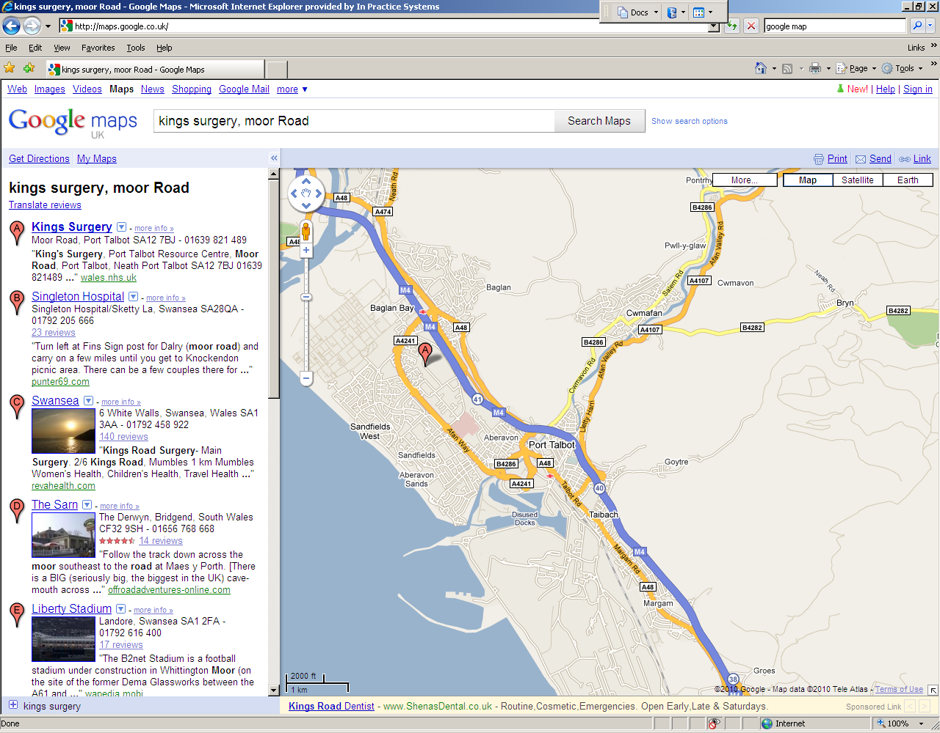

**Freedom of Information Act**

On request the practice can provide a publication that provides information on each of the Doctors and the practice.

**Information on Primary Medical Services Obtained from:**

Swansea Bay University Health Board

Block A, Neath Port Talbot Hospital

Port Talbot SA12 7BX

[**General Enquiries**](http://www.wales.nhs.uk/sitesplus/863/page/39302#general) **01656 752752**

Email: [abm.letstalk@wales.nhs.uk](mailto:abm.letstalk@wales.nhs.uk)

**Out of Hours**

Please contact: **111**

Swansea Bay University Health Board - **OUT OF HOURS**

[www.nhsdirect.wales.nhs.uk](http://www.nhsdirect.wales.nhs.uk)

**Monday - Friday 18:30-08:00**

**All Day Saturday, Sunday and Bank Holidays**

**Local walk in Centre: Minor Injuries**

Open between 7.30am and 11.00pm, seven days a week, at Neath Port Talbot Hospital, Baglan Way, Port Talbot, SA12 7BX. Contact number: 01639 862160